**SDA LAB 12**

**K20-1052**

**BSE-4B**

**TASK1**

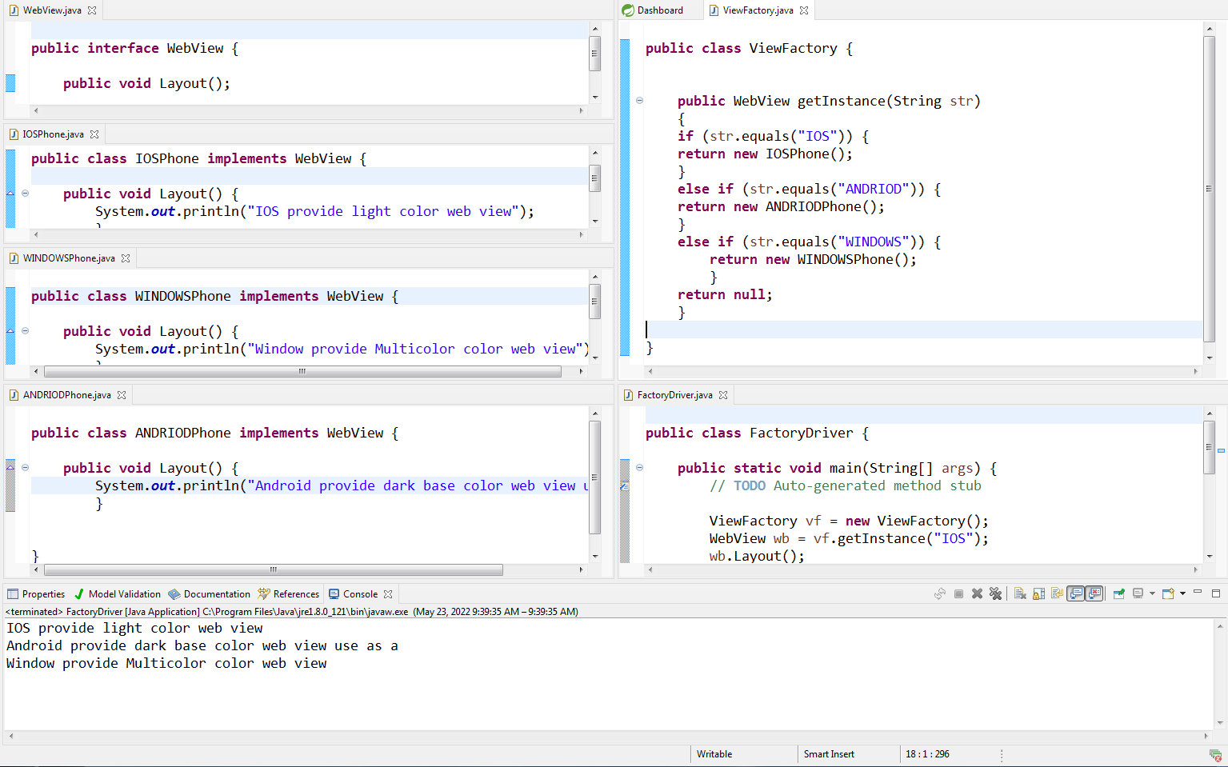

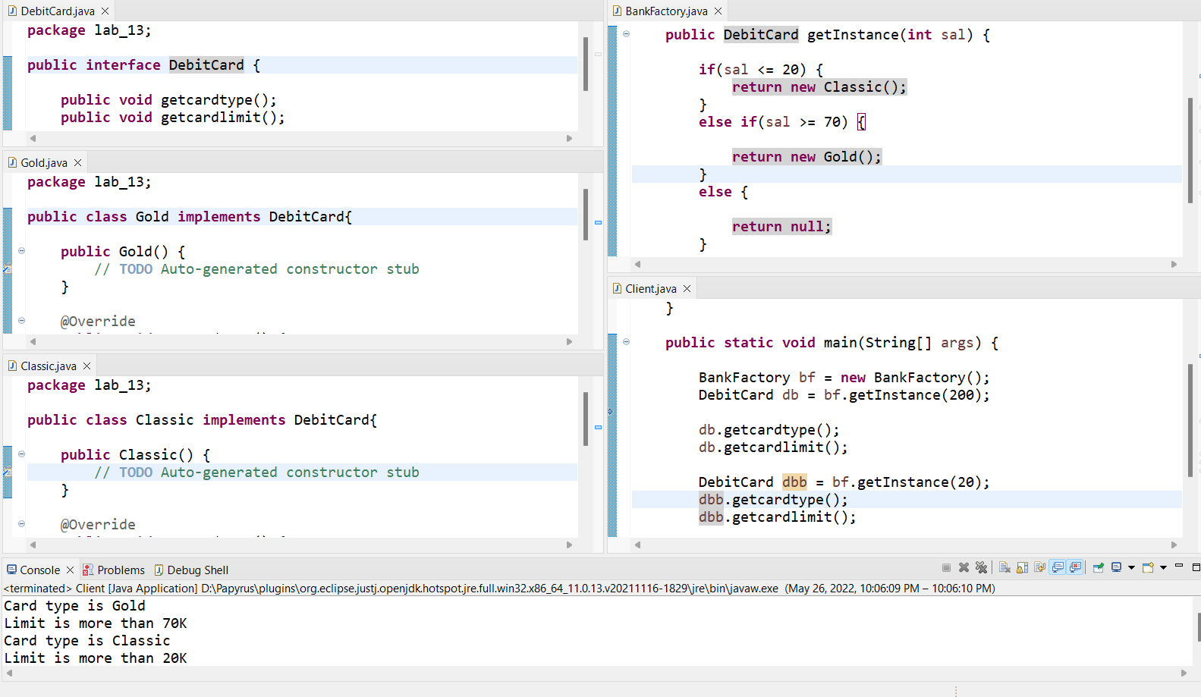**TASK 2**

**TASK 3**

**Implemented the scenario given in diagram**

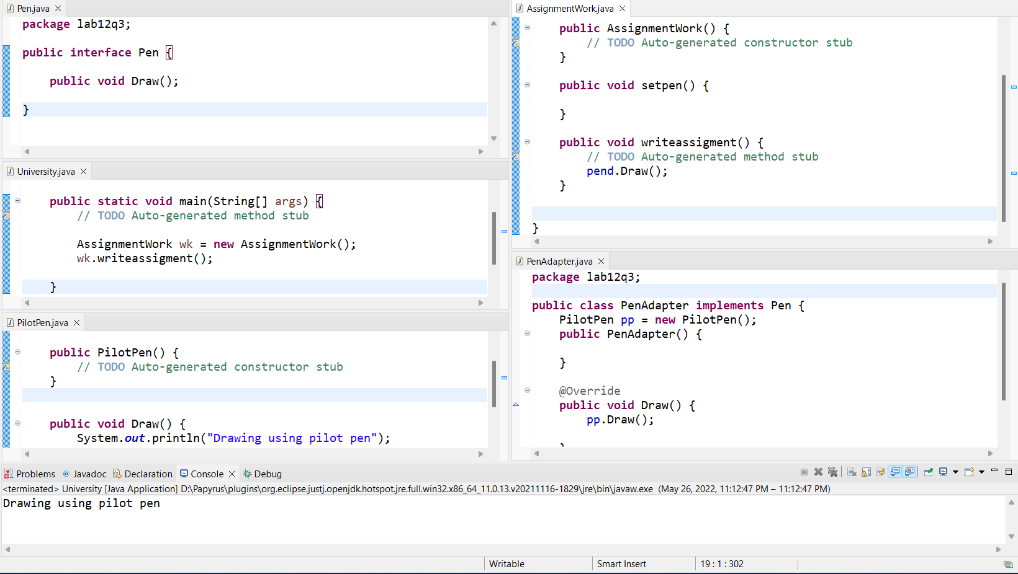

**TASK 4**

